**NAAN MUDHALVAN – GUIDED PROJECT DOCUMENTATION**

**Project title:** Tracking public infrastructure and toll payments using blockchain

**Name:** SHRIKRUPA S

**Roll no.** 2020301034

**Semester:** 07

**College Name:** Alagappa College of Technology, Anna University

**Naan Mudhalvan ID:**  1B28BFBF1322A3BA2F14FA9464FFCAD3

**Name:** SRILEKHA A

**Roll no.** 2020301035

**Semester:** 07

**College Name:** Alagappa College of Technology, Anna University

**Naan Mudhalvan ID:**  E580EED5587C82590B143399775C727D

**Name:** SRIMATHI V

**Roll no.** 2020301036

**Semester:** 07

**College Name:** Alagappa College of Technology, Anna University

**Naan Mudhalvan ID:**  5F7F9E72C93A291A0184F732C7FAE441

**Name:** SURYA A

**Roll no.** 2020301037

**Semester:** 07

**College Name:** Alagappa College of Technology, Anna University

**Naan Mudhalvan ID:**  23AC2A9C5981707B5984B771D7FA3745

**1.INTRODUCTION:**

**1.1 Project overview:**

When traveling across states or over long distances, people all over the world are required to pay tolls toward road, bridge, tunnel and other infrastructure usage. A toll is merely a fee introduced to recoup the cost of road construction and maintenance.

Designing a complete smart contract system for tracking national and state highways, toll collection, and public infrastructure on the Ethereum blockchain is a complex task that requires careful consideration of various aspects such as contract architecture, data storage, user roles, and more. Below is a simplified outline of how you could structure such a system. Please note that this is a high-level conceptual design, and you would need to work with blockchain developers and experts to implement the actual code.

Using blockchain technology, particularly the Ethereum platform, for toll payments is a concept that has been explored to enhance the efficiency and transparency of toll collection systems.

**1.2 Purpose of the Project:**

The purpose of using blockchain for tracking public infrastructure and toll collection is to achieve various important objectives that can significantly improve the efficiency, transparency, security, and overall management of these critical systems. Here are the key purposes of implementing blockchain technology in this context:

Transparency and Accountability:

Blockchain creates an immutable and transparent ledger of all transactions and actions related to public infrastructure and toll collection. This transparency enhances accountability by making all data accessible to authorized stakeholders and the public, reducing the potential for corruption and fraud.

Efficiency and Automation:

Smart contracts on the blockchain can automate many processes, such as toll collection and maintenance contracts. This reduces the need for manual intervention, streamlining operations, and reducing administrative costs.

Decentralization:

Decentralized blockchain networks reduce the dependency on a single central authority, distributing control among various stakeholders. This can help avoid single points of failure and reduce the risk of corruption.

Incentivizing Innovation:

By incorporating blockchain, governments can create an environment that incentivizes innovative solutions for infrastructure and toll collection, which can lead to more cost-effective and sustainable practices.

In summary, the use of blockchain for tracking public infrastructure and toll collection serves the purpose of enhancing transparency, reducing fraud, automating processes, and ultimately ensuring the efficient and accountable management of critical public services. It offers a framework for modernizing and improving these systems to better serve the needs of communities and governments.

**2.LITERATURE SURVEY:**

**2.1Existing Problem:**

Tracking public infrastructure and toll collection systems face several challenges and problems that can have significant economic, operational, and societal consequences. Some of the key existing problems include:

**Lack of Transparency:** Traditional infrastructure and toll collection systems often lack transparency in financial transactions and operations. Citizens and stakeholders may not have access to accurate and real-time information about how funds are collected, allocated, and utilized.

**Fraud and Corruption:** Manual and paper-based processes in toll collection can be susceptible to fraud and corruption, with the potential for embezzlement or underreporting of revenue. Mismanagement of funds can lead to significant financial losses for governments and agencies.

**Inefficiency:** Existing toll collection and infrastructure maintenance processes can be inefficient due to the reliance on manual methods, resulting in long wait times at toll booths and delayed maintenance work. Inefficient operations can lead to increased costs and reduced user satisfaction.

**Manual Record-keeping:** Maintenance records, toll transactions, and infrastructure condition data are often maintained in paper records or disparate digital systems, which are prone to human error, data loss, and difficulty in data retrieval.

**Security Concerns:** Traditional systems are vulnerable to data breaches, hacking, and unauthorized access. This can put sensitive user data and financial information at risk and erode public trust in the system.

**Delay in Maintenance:** Infrastructure maintenance is often reactive, with problems addressed only after they become significant. A lack of real-time monitoring and proactive maintenance can lead to increased costs and potential safety risks.

Using blockchain technology, as mentioned in previous responses, can help address many of these existing problems by improving transparency, accountability, security, and efficiency in public infrastructure tracking and toll collection systems. It can also pave the way for better data sharing, cross-border coordination, and public participation in infrastructure-related decisions.

**2.2 Reference:**

BEHT: Blockchain-Based Efficient Highway Toll Paradigm for Opportunistic Autonomous Vehicle Platoon - Zuobin Ying, Longyang Yi and Maode Ma

Making Toll Charges Collection Efficient and Trustless: A Blockchain-Based Approach - Swapnil Soner; Ratnesh Litoriya; Prateek Pandey

**2.3 PROBLEM STATEMENT DEFINITION**

The business problem for tracking public infrastructure and toll payments lies within the inefficiencies, lack of transparency, and potential for fraud in traditional systems

**3. IDEATION & PROPOSED SOLUTION**

**3.1 Empathy Map Canvas:**

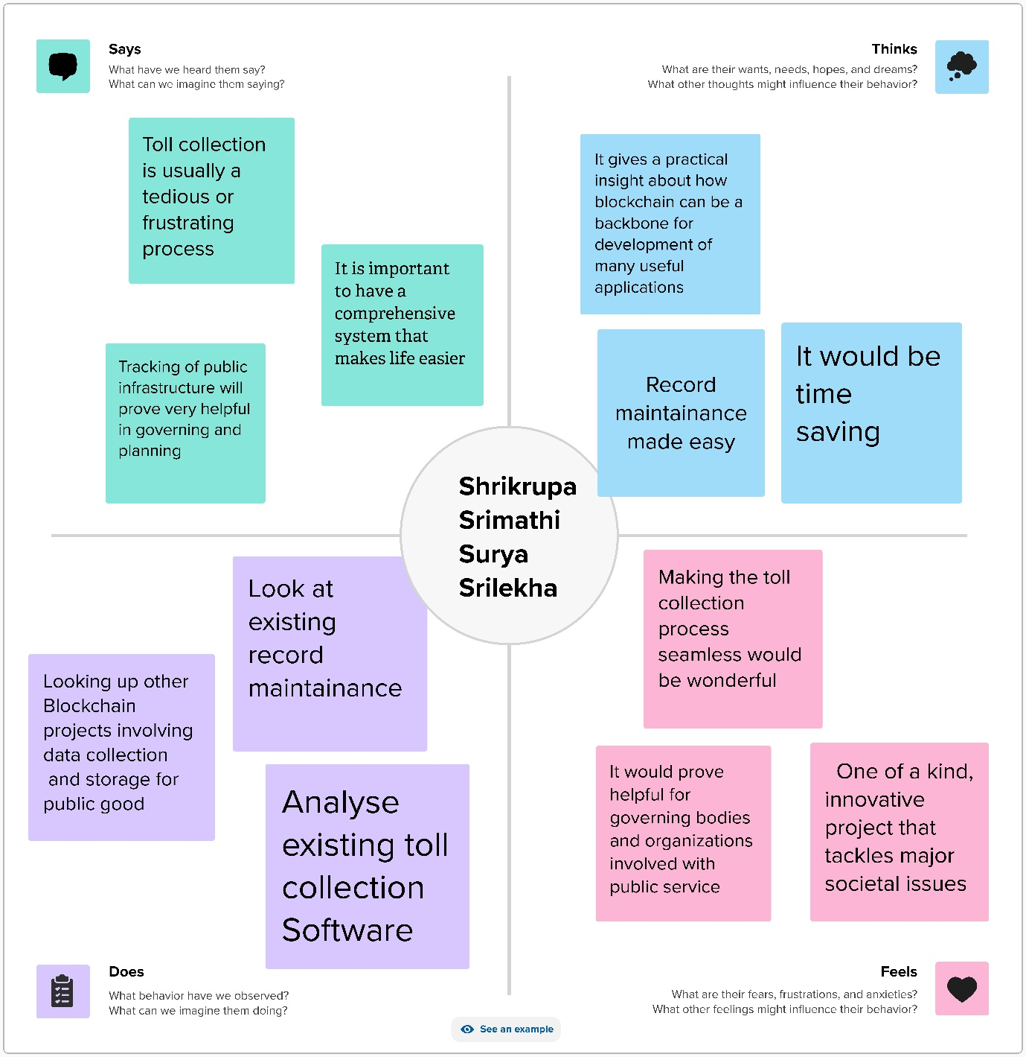

**3.2 Ideation and Brainstorming:**

**IDEATION:**

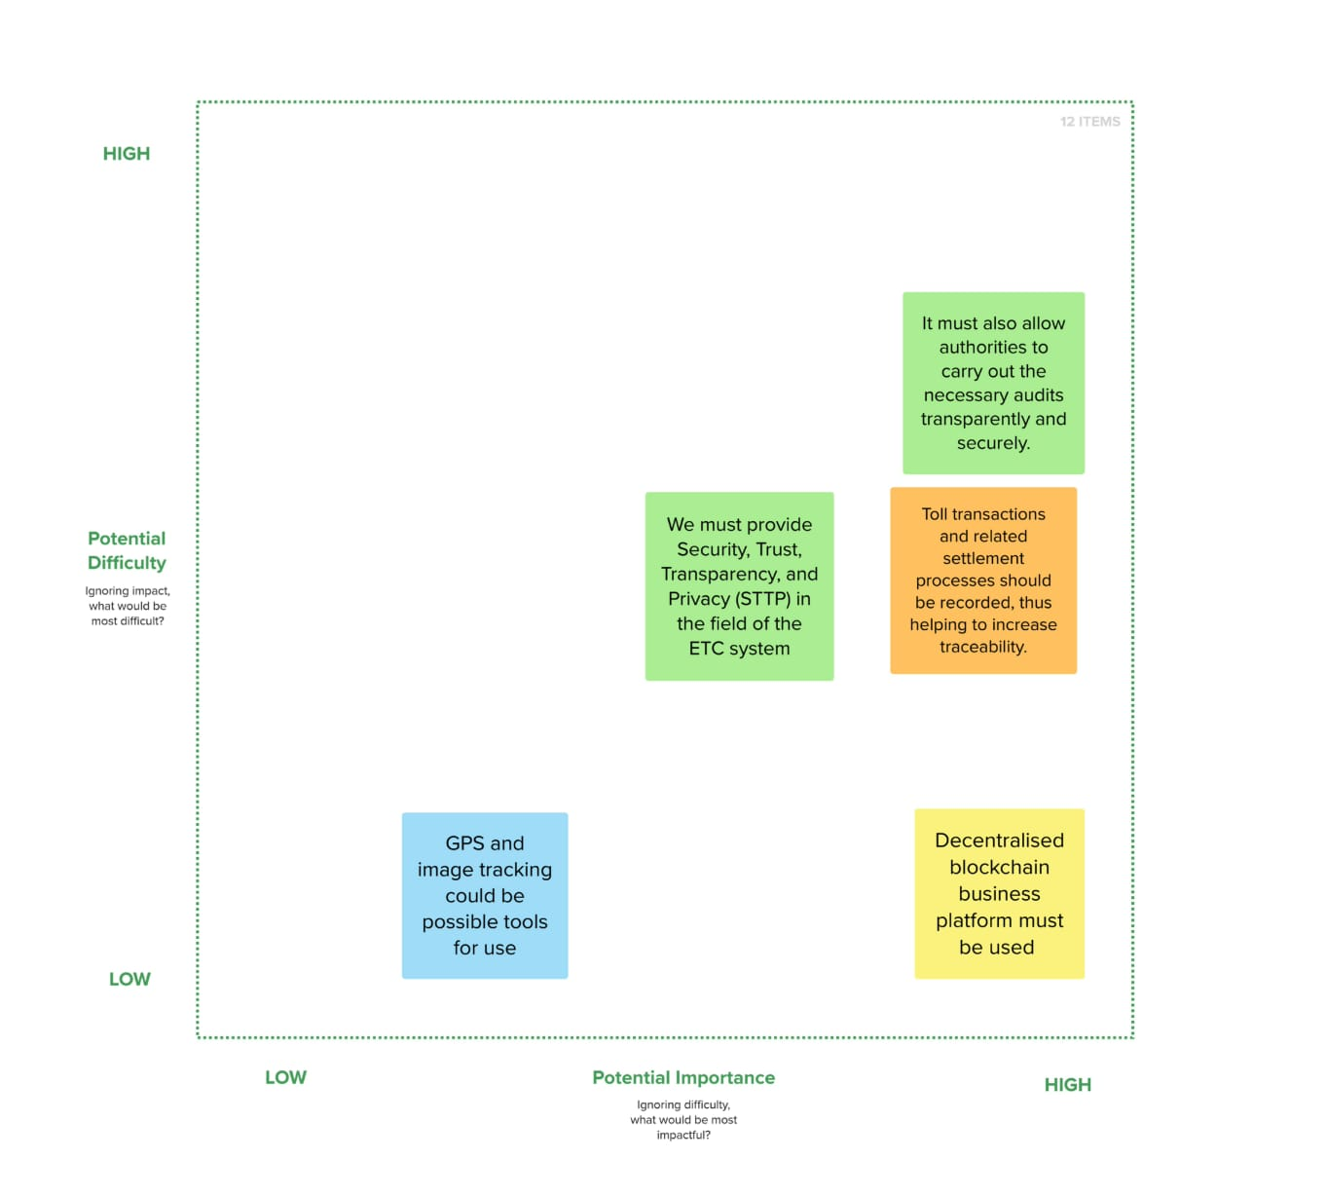

**BRAINSTORMING:**

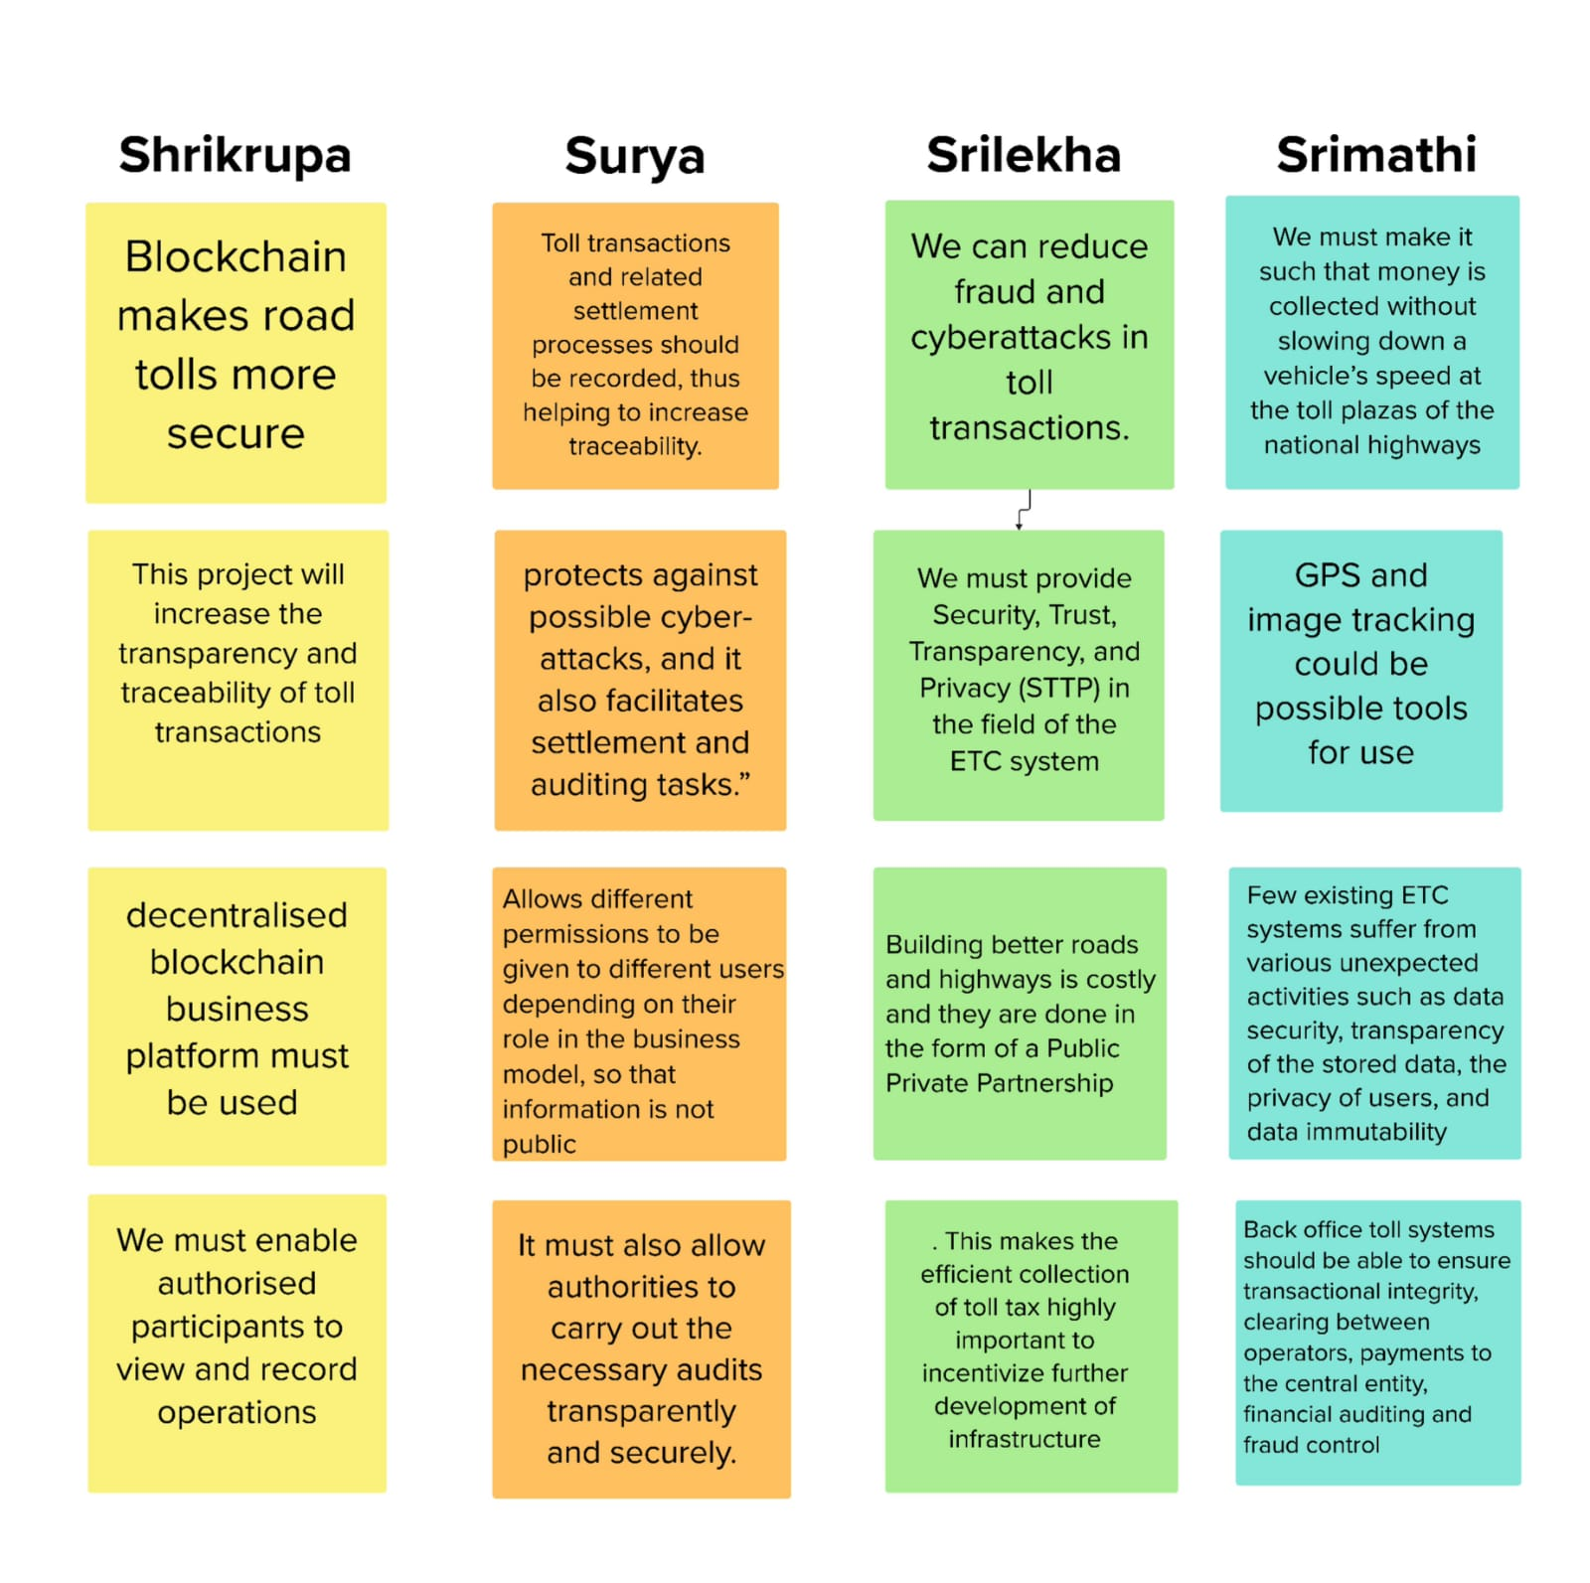

**4.REQUIREMENT ANALYSIS**

**4.1 Functional Requirements:**

The functional requirements of this project are Visual Studio Code, one remix id platform (node.js connector), file explorer, meta mask chrome extension and a source code file.

**4.2 Non-functional requirements:**

The project should have an intuitive and user-friendly interface to ensure ease of use. It should be highly available and reliable, with minimal downtime for maintenance or updates. It should be scalable to handle increased data and user loads over time.

**5.PROJECT DESIGN**

**5.1 DATA FLOW DIAGRAMS**

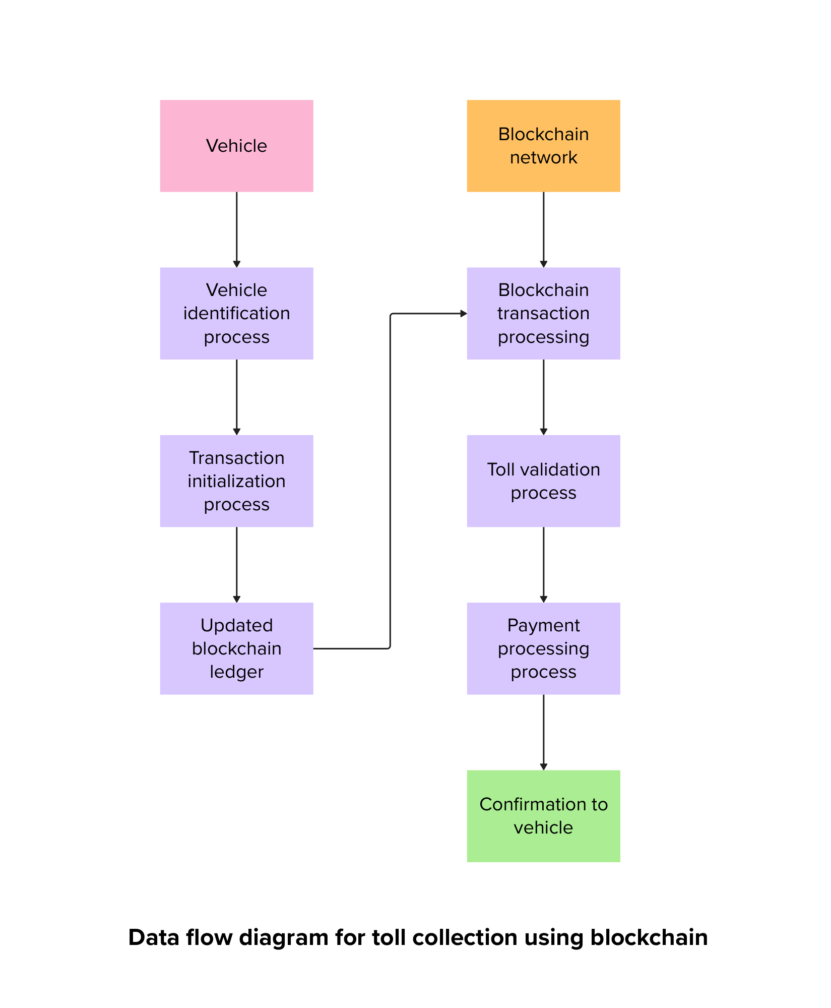

**USER STORIES:**

User stories are a useful way to outline the functional requirements of your project from the perspective of end-users and stakeholders. As an Administrator, I want user Account Management, create and manage user accounts, assign roles, and reset passwords as needed. Disable or delete user accounts when necessary. As an Educator, I want data entry and management, enter student grades, attendance records, and assessment results into the system. View and edit student information and performance data. As a Student, I want to access to Personal Data, view my own grades, attendance records, and assessment results. Access any relevant announcements or assignments from educators. As a Parent, I want to access to Child’s Data, view my child’s grades, attendance records, and assessment results. Receive notifications and updates on my child’s performance.

**5.2 SOLUTION ARCHITECHTURE:**

The architecture starts with a permissioned blockchain network. In a public infrastructure context, it's essential to ensure that only authorized entities participate in the network to maintain control and security. To improve scalability and reduce transaction costs, payment channels can be established between vehicle owners and toll booth operators. These channels allow multiple toll transactions to be batched together and settled on the blockchain periodically, reducing the number of on-chain transactions. All relevant data, such as toll transactions and vehicle ownership records, is stored on the blockchain in a secure and immutable manner. This ensures transparency and trust in the system. The blockchain network can use a consensus mechanism suitable for a public infrastructure application, such as a Proof of Authority (PoA) or a consortium-based consensus, which combines the benefits of decentralization and performance. By implementing this solution architecture, public infrastructure agencies can achieve increased transparency, reduced fraud, improved efficiency in toll collection, and a more convenient experience for both vehicle owners and toll booth operators. Blockchain technology's immutability and transparency can contribute to trust and accountability in the system.

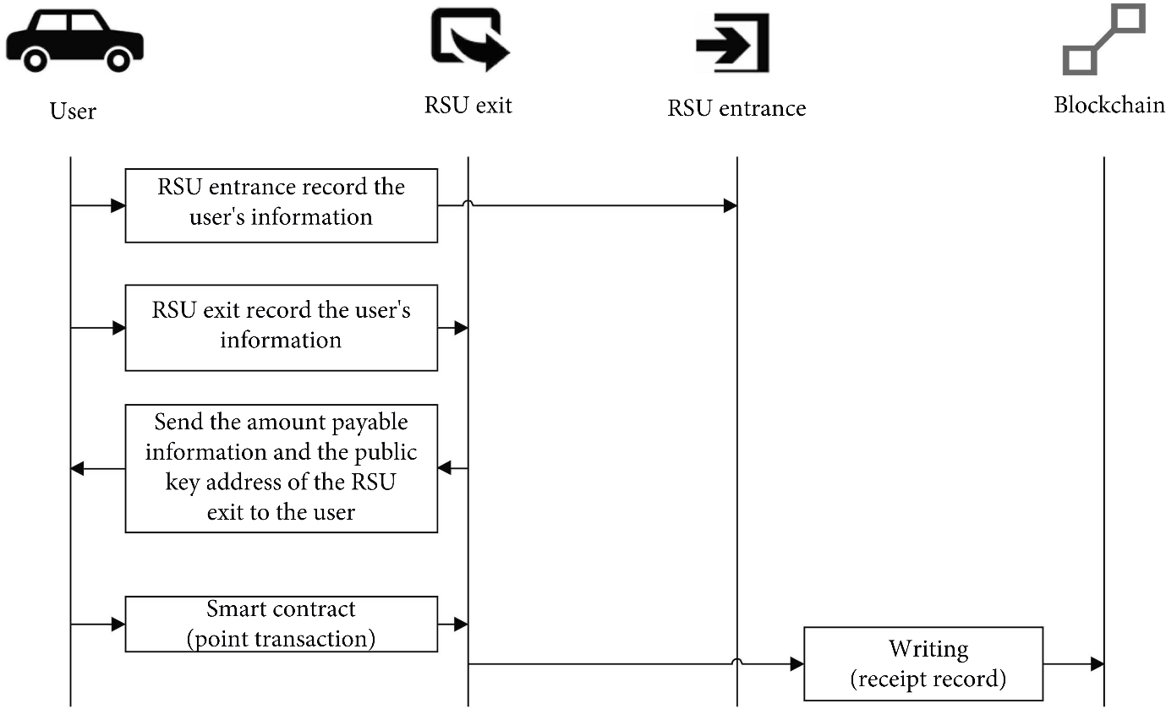

**6.PROJECT PLANNING AND SCHEDULING**

**6.1 Technical Architecture:**

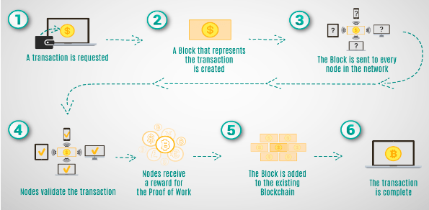

**6.2 Sprint planning and estimation for a blockchain toll collection project**

Sprint planning and estimation for a blockchain toll collection project involves breaking down the work into manageable tasks and estimating the time and effort required for each task. Here's a high-level overview of the process:

1. User Stories: Start by defining user stories or features related to the blockchain toll collection system. For example, you might have stories for user registration, toll collection, transaction recording, reporting, etc.

2. Prioritization: Prioritize these user stories based on their importance and value to the project. Identify the most critical features that need to be developed first.

3. Sprint Duration: Decide on the duration of your sprints. Common sprint durations are 2 weeks, but you can choose a duration that suits your team and project.

4. Sprint Backlog: Select a set of user stories to be included in the upcoming sprint. These stories become your sprint backlog for that particular sprint.

5. Task Breakdown: Break down each user story into smaller, actionable tasks. These tasks can include design, development, testing, and documentation.

6. Estimation: Estimate the effort required for each task. You can use techniques like story points, t-shirt sizing, or hours for estimation.

7. Capacity Planning: Determine the team's capacity for the sprint. This depends on team size and individual team members' availability.

8. Sprint Goal: Define a clear sprint goal that describes what you aim to achieve by the end of the sprint.

9. Sprint Planning Meeting: Hold a sprint planning meeting to discuss the sprint backlog, assign tasks to team members, and ensure everyone understands the sprint goal.

10. Daily Standups: Conduct daily standup meetings to track progress, identify any obstacles, and make necessary adjustments to the plan.

11. Review and Retrospective: At the end of the sprint, hold a sprint review to demonstrate the completed work and gather feedback. Follow it with a sprint retrospective to identify areas for improvement in the next sprint.

**6.3 Sprint delivery schedule for a blockchain toll collection project**

1. Sprint 1 (Duration: 2 weeks)

Sprint Goal: Establish the basic blockchain infrastructure.

Tasks: Set up the blockchain network, define smart contract structure, and create a user registration module.

2. Sprint 2 (Duration: 2 weeks)

Sprint Goal: Implement toll collection and payment processing.

Tasks: Develop the toll collection module, integrate payment gateways, and ensure secure transactions.

3. Sprint 3 (Duration: 2 weeks)

Sprint Goal: Enhance user experience and reporting.

Tasks: Improve the user interface, implement reporting and analytics features, and conduct user testing.

4. Sprint 4 (Duration: 2 weeks)

Sprint Goal: Ensure system reliability and scalability.

Tasks: Focus on system testing, optimization, and scalability testing to handle a large number of transactions.

5. Sprint 5 (Duration: 2 weeks)

Sprint Goal: Finalize documentation and prepare for deployment.

Tasks: Document the system architecture, user guides, and prepare for the production environment.

6. Sprint 6 (Duration: 2 weeks)

Sprint Goal: Deploy the blockchain toll collection system.

Tasks: Deploy the solution in a live environment, conduct user training, and monitor initial operations.

7. Sprint 7 (Duration: 2 weeks)

Sprint Goal: Post-launch optimization and support.

Tasks: Monitor system performance, address any issues, and provide ongoing support and maintenance.

**7.CODING AND SOLUTIONING:**

// SPDX-License-Identifier: MIT

pragma solidity ^0.8.0;

contract tollCollection{

struct TollData {

uint timestamp;

address collectedBy;

uint amount;

}

mapping(address => mapping(uint => TollData)) public tolls;

function payTollAmount(uint highwayId, uint _amount) public {

// TollData memory newToll = TollData(block.timestamp, msg.sender, amount);

tolls[msg.sender][highwayId].timestamp = block.timestamp ;

tolls[msg.sender][highwayId].collectedBy = msg.sender;

tolls[msg.sender][highwayId].amount += _amount;

}

function getToll(uint highwayId) public view returns (TollData memory) {

return tolls[msg.sender][highwayId];

}

// function updateToll(uint highwayId, uint amount) public {

// require(

// tolls[msg.sender][highwayId].timestamp > 0,

// "Toll data not found."

// );

// tolls[msg.sender][highwayId].amount = amount;

// }

}

**8.PERFOMANCE TESTING:**

**8.1 Performance Metrics:**

|  |  |  |  |
| --- | --- | --- | --- |
| **S.No.** | **Parameter** | **Values** | **Screenshot** |
| 1. | Information gathering | Setup all the Prerequisite: | Meta Mask Installed    VS Code Installed    NodeJS Installed |
| 2. | Extract the zip files | Open to VS code |  |
| 3. | Remix IDE  Platform exploring | Deploy the smart contract code  Deploy and run the transaction. By selecting the environment - inject the MetaMask. |  |
| 4. | Open file explorer | Open the extracted file and click on the folder  Open src, and search for utiles.  Open cmd enter command   1. npm install 2. npm bootstrap 3. npm start |  |
| 5. | LOCAL HOST IP ADDRESS | Copy the address and open it to chrome so you can see the front end of your project. |  |

**9. Results**

**9.1 Output Screenshots:**

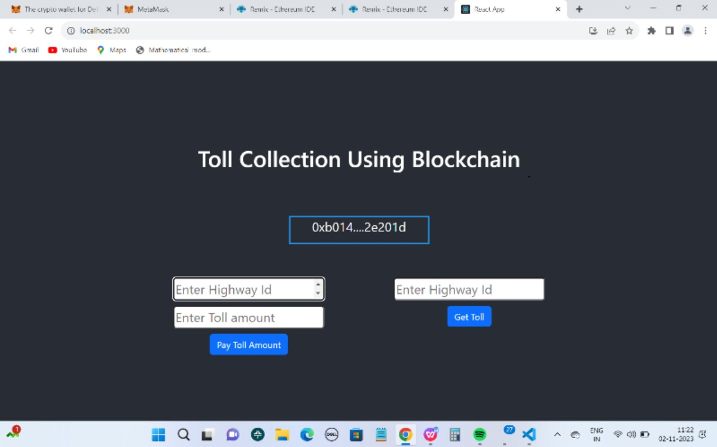

**10.ADVANTAGES AND DISADVANTAGES:**

**Advantages:**

1.Transparency and Accountability: Blockchain provides an immutable ledger that ensures transparency in toll collection and infrastructure management and improves accountability and public trust in the system.

1. Security: Block-chain's cryptographic and decentralized nature enhances the security of data and transactions, protecting sensitive information, thus increases data security and user privacy.

3. Efficiency: Automation through smart contracts streamlines toll collection and maintenance processes, enhances operational efficiency and cost savings.

4. Decentralization: Block chain reduces dependence on a central authority, distributing control among stakeholders and enhances governance and trust in the system.

5.. Interoperability: Block chain can facilitate data sharing and interoperability between various government departments thus streamlined collaboration and resource allocation is achieved

6. Incentivizing Innovation: Block chain can create an environment that incentives innovative solutions and foster innovation in the public infrastructure sector.

**Disadvantages:**

1. Implementation Costs: Initial setup and integration of block chain systems can be costly and require significant investment in technology and expertise.

2. Scalability and Performance: Due to higher volume of transactions slower transaction processing and potential bottlenecks can be of serious issues

3. Regulatory Challenges: Lack of clear regulation can be a potential barriers to implementation.

4. Energy Consumption: Some block chain networks are energy-intensive not aligning with sustainability goals increasing energy consumption and environmental concerns.

5. User Adoption and Education: Users and stakeholders may need to adapt to new block chain-based processes, requiring education and training.

**11. CONCLUSION:**

* Blockchain technology can revolutionize toll payments by providing a secure, transparent, and efficient system that eliminates many of the existing challenges in traditional toll collection methods.
* By leveraging the decentralized and immutable nature of blockchain, toll operators can enhance the user experience, reduce fraud, and streamline their operations. This technology enables seamless, real-time payment processing, reducing congestion and improving overall traffic flow.
* The transparency of blockchain can build trust among users, as they can track and verify their transactions, ensuring that tolls are fairly and accurately assessed.

In conclusion, the application of blockchain in toll payments has the potential to enhance efficiency, transparency, and security, making it a compelling choice for the modernization of toll collection systems.

**12. FUTURE SCOPE:**

Here are some future scope and applications for blockchain technology in these areas:

* **Transparent and Efficient Toll Collection:**

Creating a transparent and efficient toll collection system and Smart contracts can automate the process, ensuring that tolls are collected accurately and in real-time. This can reduce the likelihood of toll evasion and improve revenue collection for maintaining and upgrading public infrastructure.

* **Decentralized Toll Management:**

A decentralized blockchain-based system can eliminate the need for a central authority to manage toll collection, reducing the risk of corruption and improving accountability. Toll revenue can be distributed directly to the relevant government agencies and infrastructure providers, streamlining the financial aspect of public infrastructure projects.

* **Maintenance and Asset Tracking:**

Blockchain can be used to track the maintenance and repair history of public infrastructure assets, such as bridges, roads, and tunnels. Maintenance records, sensor data, and inspection reports can be stored on a blockchain, providing a tamper-resistant and transparent history of asset management.

* **Crowdsourced Traffic Information:**

Blockchain can incentivize users to contribute traffic data, such as congestion reports, road conditions, and accident information, by rewarding them with tokens or cryptocurrency. This data can be used to improve traffic management and infrastructure planning.

* **Disaster Recovery and Resilience:**

Creating a decentralized backup system for critical traffic infrastructure data in case of disasters or cyberattacks ensures the continued functionality of traffic systems.

* **Environmental Impact Monitoring:**

Monitoring the environmental impact of traffic infrastructure projects and data related to emissions, noise levels, and other environmental factors can be recorded on a blockchain to ensure compliance with regulations and support environmentally friendly infrastructure development.

The successful implementation of blockchain in these areas will require collaboration between governments, technology providers, and stakeholders to ensure its widespread adoption and effectiveness.

**13. APPENDIX**

**SOURCE CODE:** <https://drive.google.com/file/d/1ZE8BNn8SkAnh3qFkGB1FCvnESX8I_WtK/view?usp=sharing>

**GITHUB LINK:** <https://github.com/toll-payments/toll-collection>

**PROJECT DEMO LINK:** <https://drive.google.com/file/d/1zayQy8aqjCIwGn-m8G_5xCw60G0CktfQ/view?usp=sharing>